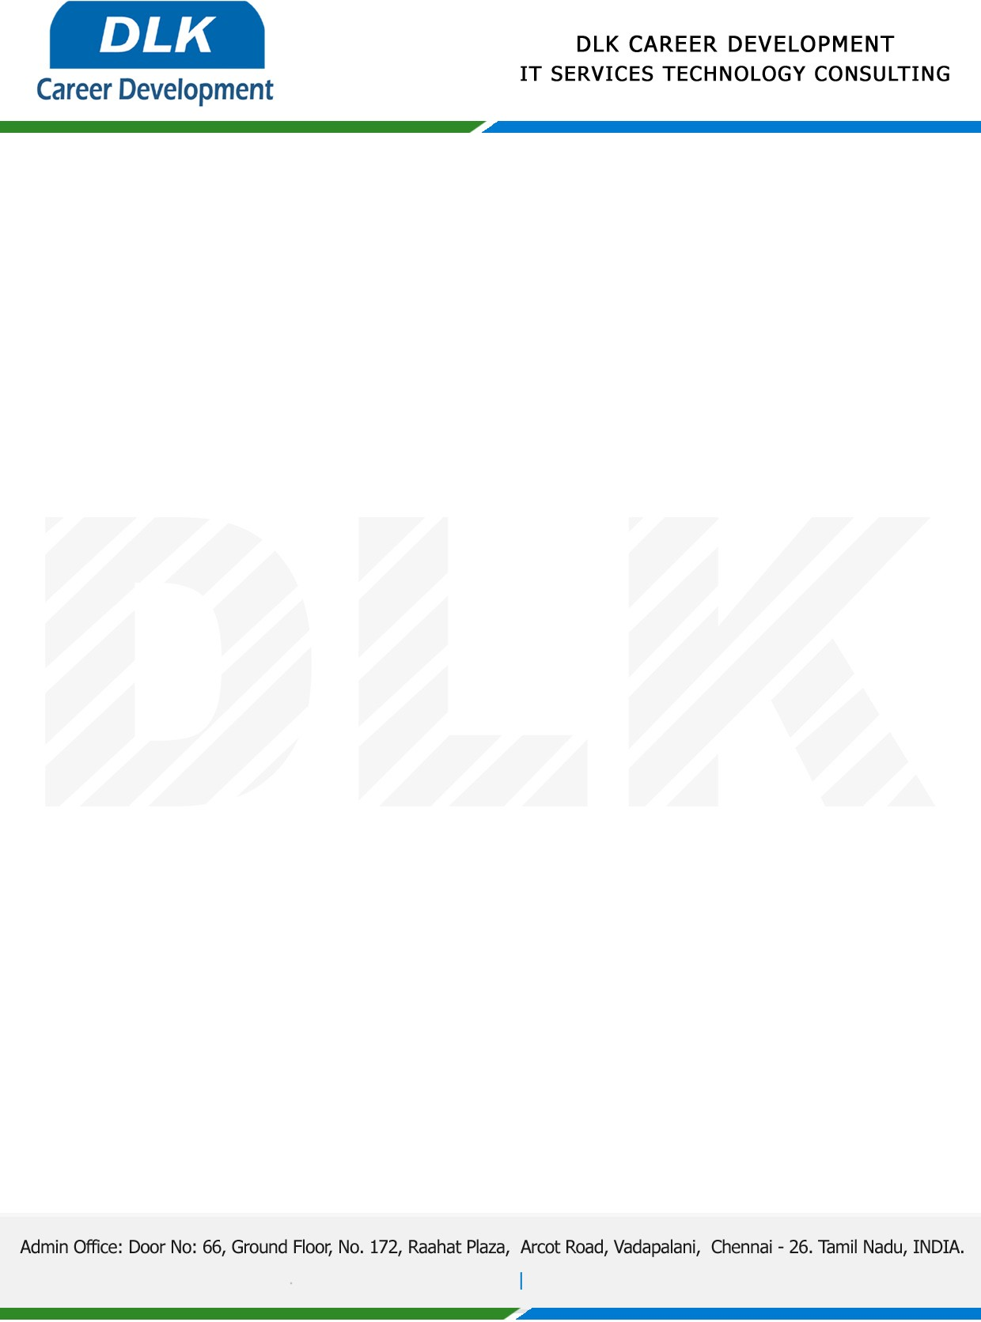

**Date: 19/January/ 2023**

**SUB: PROJECT COMPLETION LETTER**

This is to certify that **MS SHREENIDHI G (REG NO: 113220041127) BE- Electronics and Communication Engineering,** third year student at **Velammal Engineering College, Chennai** has Successfully Completed her Project Work under the domain of “**Data Mining”** in our organization during the Period **(26th December 2022 to 11th January 2023).** During the internship, all information and data collected from you should be kept confidential.

**Topic:** Student's Academic Performance through Exploration of Student's Background and Social Activities

We appreciate your interest in **DLK CAREER DEVELOPMENT**

**“Best Wishes for Your Future Endeavors “**

For **DLK CAREER DEVELOPMENT**

**HR Manager**

**VELMURUGAN J**